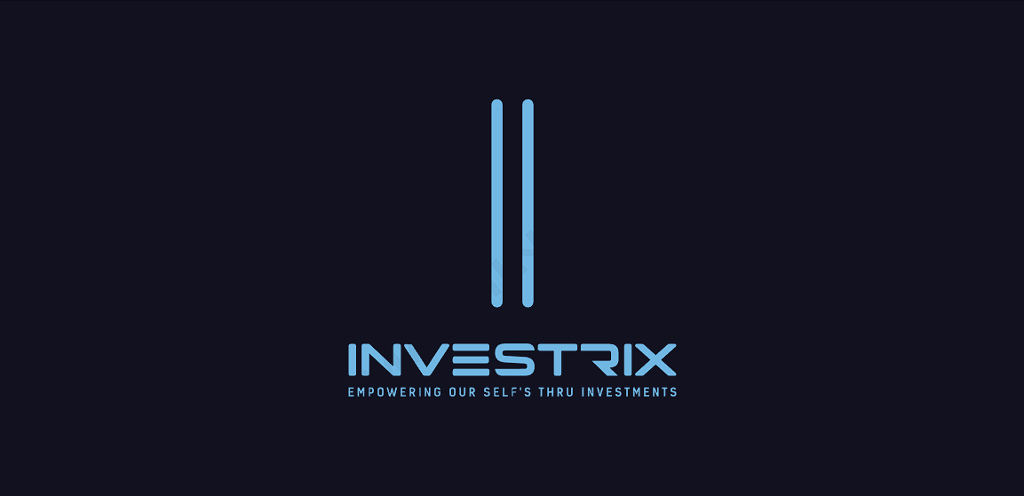

Dear [Client's Name],

I hope this letter finds you well. We greatly appreciate the opportunity to discuss the prospect of our investment in your company, [Client's Company Name]. As we continue to work towards a successful partnership, we wanted to provide you with some important information regarding the terms and conditions associated with this potential investment.

Firstly, regarding the investment in your company, we have set the minimum call option fee at R2500. This amount represents the absolute minimum that we can accept to initiate this investment. The call option fee is a crucial component of this strategic partnership, the prescribed fee will be determined as 1% of the company's total value multiplied by the percentage of ownership we will hold. This fee is further divided by 12 months, which allows us to align the compensation structure with our financial calendar.

Secondly, for the Non-Executive position, the remuneration is set at a monthly rate of R5000 per month, and we want to emphasize that this rate is non-negotiable. We are confident that this compensation is competitive and fair within the industry, and it aligns with our internal compensation standards. Furthermore, we have established a minimum annual increase of 5% in the remuneration to ensure that your contributions and commitment are duly recognized as our partnership evolves.

Our objective is to establish a strong and lasting relationship with you as a valued partner. These terms and conditions are designed to provide clarity and transparency from the outset, ensuring that our partnership is built on a strong foundation of trust and mutual understanding.

We are excited about the potential of this partnership and the contributions you will make to [Your Company Name]. We look forward to further discussions and, hopefully, formalizing this agreement soon.

Thank you for considering this partnership with [Your Company Name]. We greatly appreciate your interest and are eager to embark on this journey together.

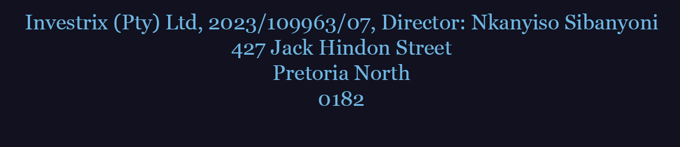
Sincerely,
Nkanyiso Sibanyoni
Managing Director

